Mobile review
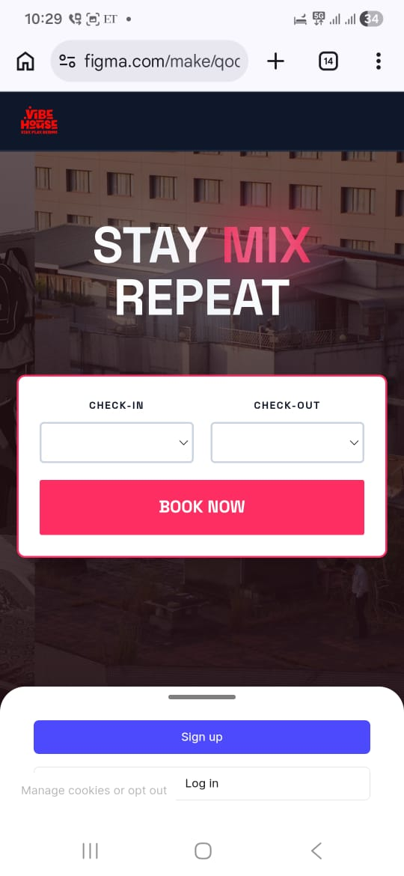
Comments
- Book now tab is on the centre, which is not ideal, keep the centre or hero screen for showing best image with content which create excitement to book instantly.
- Book now is there but doesn’t show any urgency and booking CTA is getting lost. Probably put a note or tag of ( Starting at 599 tonight , or Only XX beds left, book now to claim discount of xx%, etc)
- Black BG doesn’t look very appealing should see the reference of Gostops, they have colourful logo, however have kept the BG white only check if this make sense.
- Category – Hostels , Colive , Group

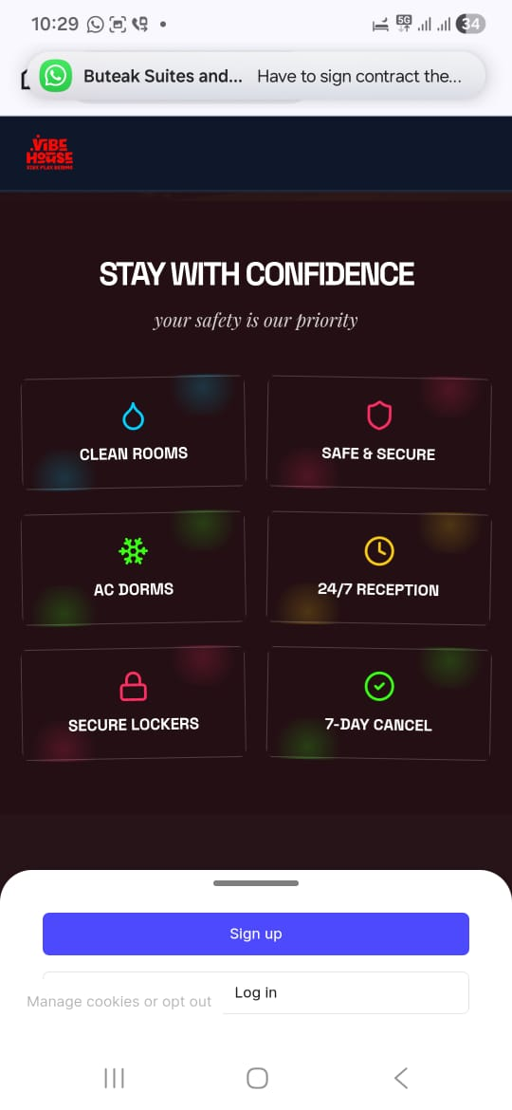

Comments
- Font we should see some other options.
- Too many colors, we should remove the BG flow of lights.
- Make this section shorter since or can it be merged with room + amenities?
- Currently the flow is :
- Hero
- Safety
- Amenities
- Rooms
- Experience
- Events
- Reviews
- CTA Again.
This is too long for mobile
Can we do :
Hero – Header ( Hostels, Partner with us, Contact us , Long Stays )
Why Vibe House – Experience
Room + Amenities
Activities
Review
Then everything else like ( Host a free event , Partner with us ) etc.

